# Technical Assessment – Meghana Dixit

Contents

1. Login Page
2. Top Bar Menu
3. Charts
4. Buyers
5. Invoice Addition
6. Invoice List
7. Tables and Stored Procedures

# Login Page

* The Login page is where the end user logs into the application.
* Below is the screenshot of the Login page.
* Username – meghana and Password- Atcat1234$$
* The user is created in the backend- SQL Server

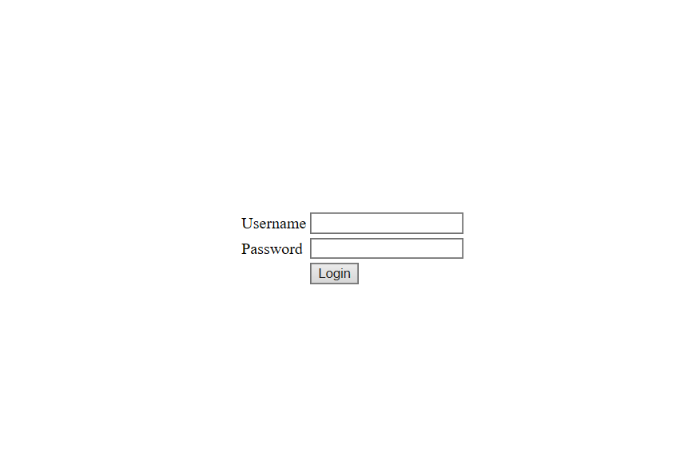

# Top Bar Menu

* Invoice List- List of invoices coming from database and having export function to export data to excel file.
* Buyers: Details of Prospective Buyers.
* Invoice Addition: Adding invoice Details and those added details will be visible Invoice list Tab
* Charts fetching data from SQL Server Database ( coming on home page as suggested).



# Default Page having Charts:

Home Page has 4 charts –

* Customers Based on Region – Column Chart
* Customers Based on Region – Pie Chart

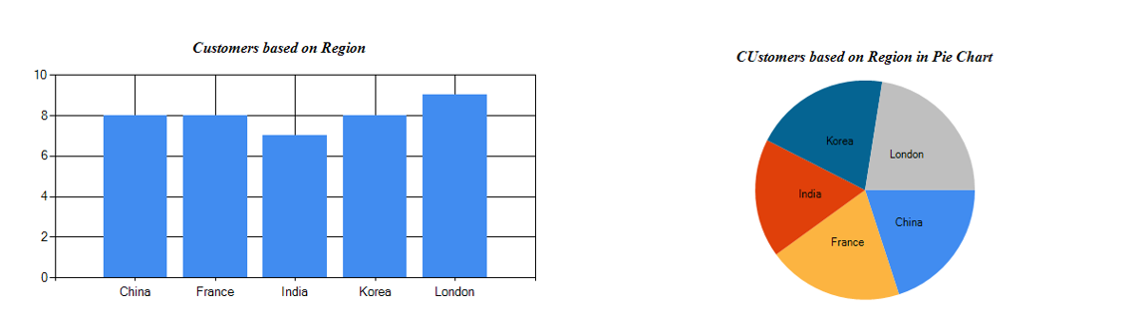

* Revenue Generated by Employees– Bar Chart
* Revenue Generated by Employees – Line Chart

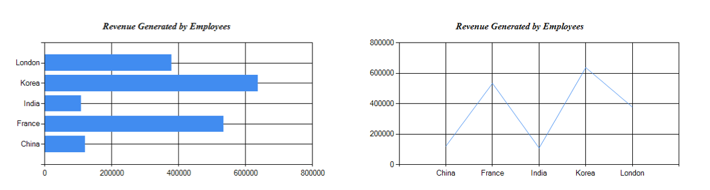

# Prospective Buyers

This Page has the list of the buyers/ customers from different regions.

* The Grid view had 6 columns – Name, Gender, Email, Salary and Country.
* Pagination is included to help the user to navigate further in the list

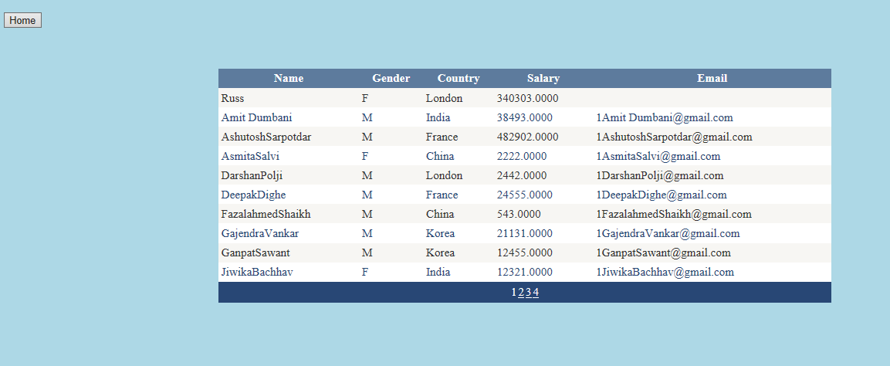

# Invoice Addition

Create Invoice helps the user to create the invoices in the database in the table. The page has the following fields

* Invoice Number – Free and alphanumeric text field
* Invoice Amount – Free and numeric text field
* Invoice Type – PO or Non-PO invoice type
* PO Number – Purchase Order number.
* Company – Free text field
* Country – Free Text field

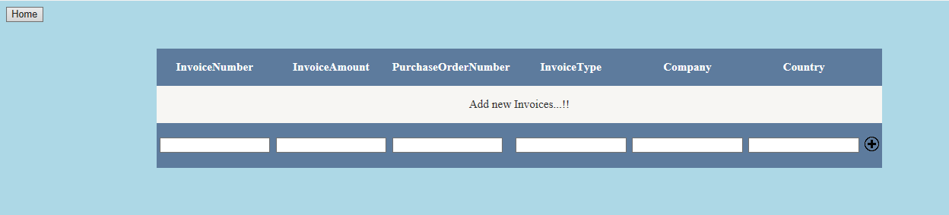

# Invoice List

List invoice fetching detail from Database. Having Export Functionality.

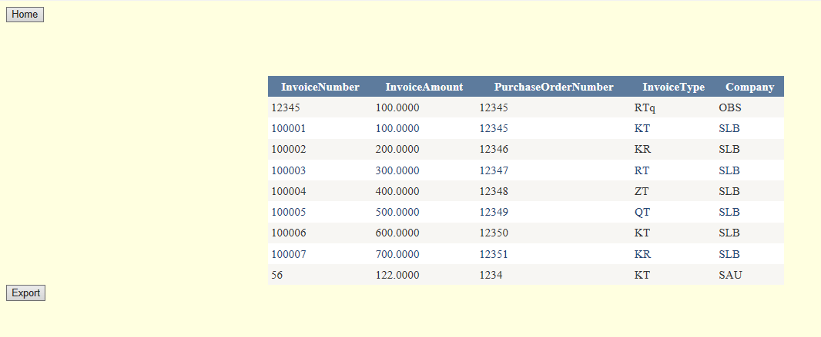

# Tables and Stored Procedures

* dbo.InvoiceDetails – Table saves the Invoice details.
* dbo.Users – User details are saved.
* TblEmployee- Table stored buyers details and showing charts data from this table
* [GetBuyerDetails]- Invoice list data coming from this proc
* [GetInvoiceDetails]- For invoice addition we call this proc.